

|  |  |  |  |  |  |  |  |  |
| --- | --- | --- | --- | --- | --- | --- | --- | --- |
|  | | | | | | | | |
|  | | Week 2 Lab: Relationships and Normalizations | | | | |  | |
|  |  | | | | | | |  |
|  | | | |  |  | | | |
|  | | | | Christine Baxter |  | | | |
|  | | | | July 18, 2021—Developing and Managing Databases for Business IntelligenceBIAM530—Robert Burdwell |  | | | |
|  | | |  | | |  | | |



|  |  |  |  |  |  |  |  |  |
| --- | --- | --- | --- | --- | --- | --- | --- | --- |
|  |  | | |  |  | | |  |
|  | Abstract | | | | | | |  |
|  |  | | |  |  | | |  |
|  |  | |  | | |  | |  |
|  |  | The database development process consists of four main stages which start with requirement analysis and end with implementation. Requirement analysis encompasses interviewing producers and users of data as well as creating data requirement specifications. The conceptual model provides a global view of organization’s data and the logical model identifies/handles relationships and normalizations. Each stage within the process is critical to producing a successful database project implementation. | | | | |  |  |
|  | | | | |
|  |  |  |  |
|  |  |

|  |  |  |  |  |  |  |
| --- | --- | --- | --- | --- | --- | --- |
|  | | | | | | |
|  | | Introduction | | |  | |
|  | |  |  |  |  | |
|  | The XYZ Veterinary Clinic needs a way to keep track of clients, patients, veterinarians, appointments, and procedures as well as invoicing and other financial aspects. The business rules and requirements were gathered by discussing the structure of data needed and use of that data within the business’s environment. It was critical to have these discussions with primary stakeholders and users. Following these requirement gathering meetings, a business decision was made by the leadership team to focus on the non-financial aspects first. As a result, this recommendation does not include tables, attributes, or relationships for the invoicing and/or financial side of the business. However, this first phase of the project was built/developed with understanding the goal of incorporating the financial aspects in the next phase.  This report will begin by briefly discussing the database development process. We will then provide further detail on the requirement analysis stage as well as discuss conceptual and logical diagrams including relationships and data types among these items. We will conclude with recommendations of design and next steps. | | | | |  |

|  | | | | | | |
| --- | --- | --- | --- | --- | --- | --- |
|  | | Database Development Process | | |  | |
|  | |  |  |  |  | |
|  | As shown in *Figure 1. Database Development Process*, the database development process consists of four main stages which start with requirement analysis and end with implementation. For this project, the requirement gathering stage was completed through meetings/interviews with primary stakeholders and users as well as leadership team. From this, the Information Requirements and Business Rules were determined. The next step was to create the conceptual data model, including all entities (important business/organization data) with correct names and required relationships as well as indicating the correct cardinalities using crow’s foot notation. The conceptual model was used to create the more detailed logical data model that indicates reasonable attributes (information need to store) for each entity with appropriate data types, correct designations of primary and foreign keys, and a visually organized, readable layout  (SQL Database Tutorials, 2020). | | | | |  |

|  |  |  |  |  |  |  |
| --- | --- | --- | --- | --- | --- | --- |
|  | | | | | | |
|  | | Information Requirements | | |  | |
|  | |  |  |  |  | |
|  | XYZ Veterinary Clinic needs up-to-date information for animals, animal owners, and veterinarians. It is essential the clinic is recording/tracking the detail of appointments and procedures/treatments performed during those appointments. In addition, for scheduling purposes, it is necessary to know which veterinarians are available or already booked (DeVry University, 2021). Animals Animals are referred to as patients. The details of the animals include their identification (ID) code and associated animal owner ID, name, date of birth, gender, type of animal (e.g., cat, dog, etc.), breed of animal (e.g., pit bull, Australian sheep dog, etc.), and sterilization status (e.g., spayed, neutered, intact). In addition, the animals age is derived using a computational formula producing an interval value for the difference between date of birth and current system date. Animal Owners Animal Owners are referred to as clients. The details of the animal owners include ID code, name, address, telephone, and social security number. Veterinarians The details of the veterinarians include their ID code, name, telephone, clinic location, and specialty. | | | | |  |

|  |  |  |  |  |  |  |
| --- | --- | --- | --- | --- | --- | --- |
|  | | | | | | |
|  | | Information Requirements (continued) | | |  | |
|  | |  |  |  |  | |
|  | Appointments Tracked details of patient (animals) appointments include appointment number, date, start and end time as well as the associated client, patient, and veterinarian. Procedures Procedures are veterinary procedures, such as tests or treatments performed during appointments. The details tracked for procedures include the procedure code and name. In the future, procedure price can be added to the tracked detail. | | | | |  |

|  |  |  |  |  |
| --- | --- | --- | --- | --- |
|  | | | | |
|  | Business Rules | | |  |
|  |  |  |  |  |

The external model, also known as the end-user view, was used to produce the business rules listed below. This process provided feedback to the designer about the model’s accuracy, confirming it supported all defined processes in addition to any operational requirements/constraints (SQL Database Tutorials, 2020).

1. Each Client owns zero or many Patients; each Patient is owned by exactly one Client.
2. Each Patient can have zero or many Appointments; each Appointment is for exactly one Patient.
3. Each Appointment is with exactly one Veterinarian; each Veterinarian can have zero or many Appointments.
4. Each Procedure can be performed during zero or many Appointments; each Appointment can include the performance of zero or many Procedures.

|  |  |  |  |  |
| --- | --- | --- | --- | --- |
|  | | | | |
|  | Conceptual/Logical Models | | |  |
|  |  |  |  |  |

##### Conceptual Model

The conceptual model was used since it provides a high-level, global view of the organizations data environment. This model is independent of both software and hardware, meaning changes in either the hardware or database management software (DBMS) will not have an effect at the conceptual level. Refer to *Figure 2. Conceptual Entity Relational Diagram* for detailed diagram.

##### Logical Model

The purpose of the logical model is to map the conceptual model to the selected DBMS. As mentioned in the introduction, it was determined to use a relational database for this project. As a result, the entities contained in the conceptual model were mapped to tables within the relational model then attributes, data types, and keys were added. Please note this model is considered software dependent (depends on specific database used) and hardware independent (change in storage device or operating system does not affect logical model). The logical model also identifies and addresses any many-to-many relationships/cardinalities present within the conceptual model. The completed diagram was reviewed and checked for normalization forms. Refer to *Figure 3. Logical Entity Relational Diagram* for detailed diagram. Within the logical model, normalization represents a micro view of the ERD entities and is void of any unnecessary redundancies that may cause data anomalies. There are several different levels of normalization checks. For this project, the third normal form (3NF) was implemented (Coronel & Morris, 2019).

|  |  |  |  |  |
| --- | --- | --- | --- | --- |
|  | | | | |
|  | Design Recommendations | | |  |
|  |  |  |  |  |

Using and implementing a cloud relational database will provide the XYZ Veterinary Clinic with many benefits such as feasibility for future modifications, data accuracy and integrity, high security, and reduction of data redundancy to minimum or zero. This type of database allows the user to classify data into different categories, modeling business processes and then stores the data efficiently. (UKEssays, 2018)

With the proposed conceptual (*Figure 2*) and logical (*Figure 3*) diagrams, the XYZ Veterinary Clinic will be able to meet the needs for up-to-date information on animals, animal owners, and veterinarians ultimately increasing customer satisfaction which can have a direct impact on the organization’s growth. In addition, the clinic will have a reliable and efficient way to record/track the detail of appointments and procedures/treatments performed during those appointments. The clinic’s customers and staff will benefit from accurate scheduling of appointments and veterinarian’s time/expertise avoiding situations where veterinarians could be double/triple booked or just unavailable.

|  |  |  |  |  |
| --- | --- | --- | --- | --- |
|  | | | | |
|  | Next Steps | | |  |
|  |  |  |  |  |

Following the decision to move forward with this design, we would propose the next steps (Ramadhan, 2021):

1. Present the logical database design to stakeholders and users for a final review and feedback process
2. Make any needed modifications, confirming the 3NF was kept intact
3. Move to the Physical Database Design stage
   1. Determination/selection of:
      1. Records organization
      2. File organization
      3. Use of indexes (access methods)
   2. Discussions related to partitioning and clustering of data
4. End with Database Implementation stage
   1. Creating and updating of database
   2. Loading data into database tables
   3. Operation and monitoring
      1. Preventive maintenance (backup)
      2. Corrective maintenance (restoration)
      3. Adaptive maintenance (improving performance, adds entities and attributes)
      4. Assignment of permissions and maintenance for new/old users
      5. Database access statistics for improving efficiency and monitoring system performance
      6. Security audits
      7. Usage summarization for billing/budgeting purposes
   4. Redesign/improvement (modifications when requirements change)

|  |  |  |  |  |
| --- | --- | --- | --- | --- |
|  | | | | |
|  | FIGURE(S) | | |  |
|  |  |  |  |  |

Figure 1. Database Development Process 12

Figure 2. Conceptual Entity Relational Diagram 13

Figure 3. Logical Entity Relational Diagram 14

Figure 1. Database Development Process

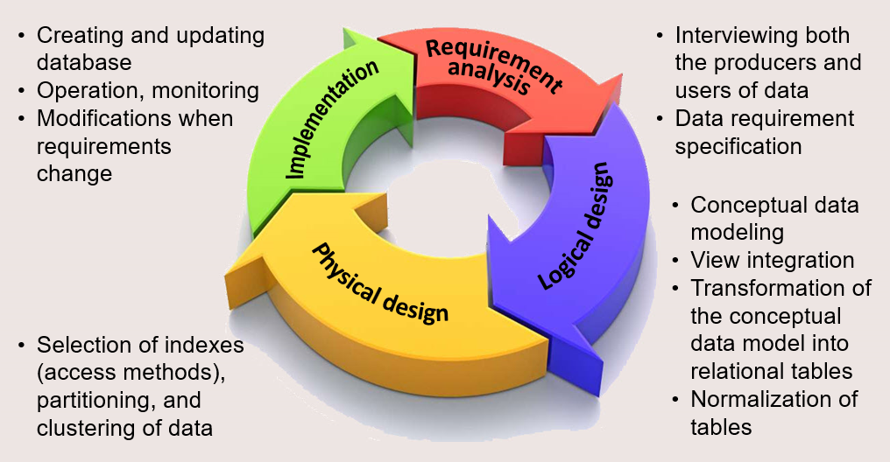

Source: (Ramadhan, 2021)

Figure 2. Conceptual Entity Relational Diagram

Figure 3. Logical Entity Relational Diagram

|  |  |  |  |  |
| --- | --- | --- | --- | --- |
|  | | | | |
|  | References | | |  |
|  |  |  |  |  |
| Coronel, C., & Morris, S. (2019). *Database Systems: Design, Implementation, & Management* (13th ed.). MindTap - Cengage Learning.  DeVry University. (2021). *Week 2: Lab Overview*. Retrieved from devryu.instructure.com: https://devryu.instructure.com/courses/70082/pages/week-2-lab-overview?module_item_id=8715940  Ramadhan, M. (2021, June 22). *The Database Life Cycle*. Retrieved July 18, 2021, from Medium: https://medium.com/informatics/the-database-life-cycle-4151969ca57d  SQL Database Tutorials. (2020, April 2). *Preparing Written Documentation | Presenting Database Projects*. Retrieved from SQL Database Tutorials: https://sqldatabasetutorials.com/sql-db/preparing-written-documentation/  UKEssays. (2018, November). *Database Design And Development For Petcare Veterinary Computer Science Essay*. Retrieved from UKEssays.com: https://www.ukessays.com/essays/computer-science/database-design-and-development-for-petcare-veterinary-computer-science-essay.php | | | | |
|  | | | | |